CAED Support Shops

**Planer**

**•Review dress code**

-Remind students that long hair must be tied back, loose clothing and/or jewelry must be removed

**•Intro**

-Discuss what the tool does/strengths

-Removes material from top

-Dimensions material to precise thickness

-Does not flatten material like the jointer, if the material is warped going in it will be warped coming out

-Describe the cutter head location and direction of rotation

-Describe the infeed, outfeed, and bed rollers, and the anti-kickback fingers

-Describe/show grain direction

-Emphasize by drawing on edge of material

-Explain/Show how this relates to feed direction

-Show how flipping material end for end maintains correct feed/grain direction

-End grain will tear out and is not advisable for the planer

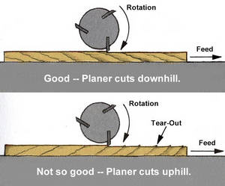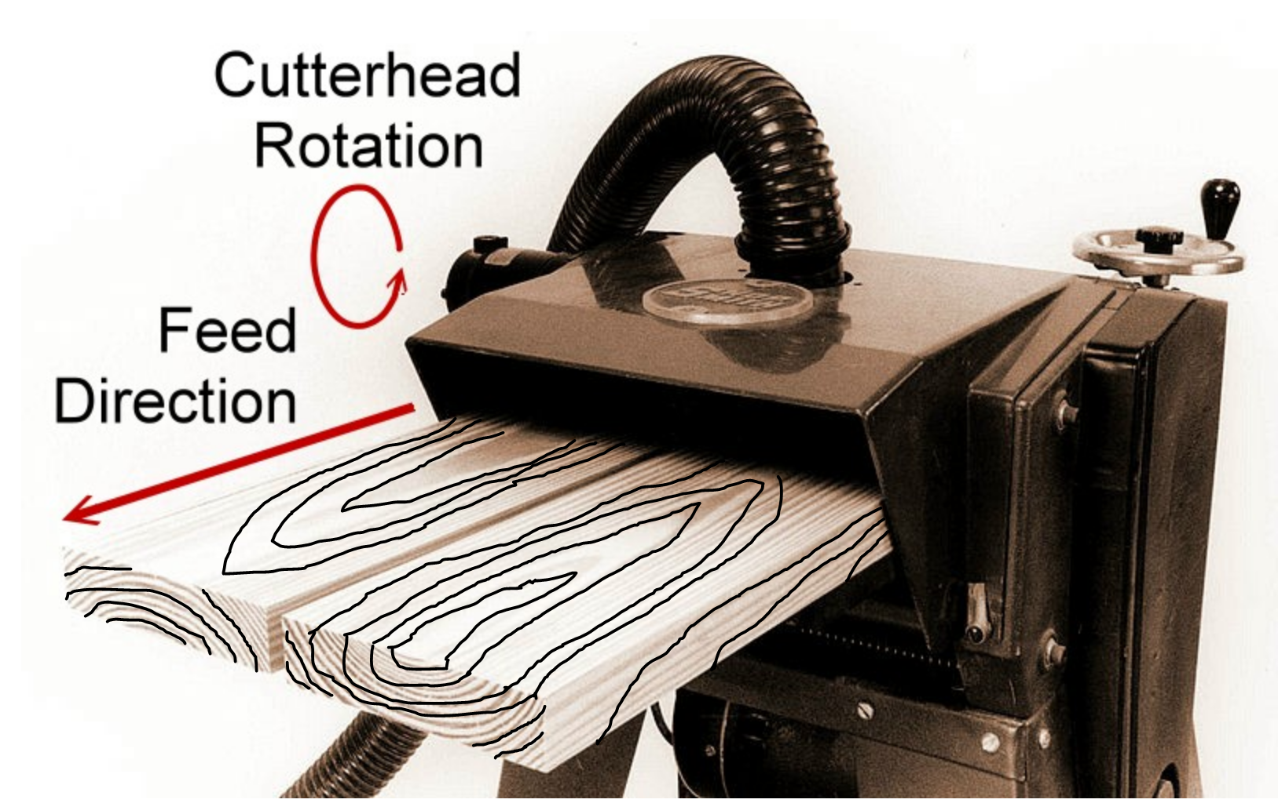

Bark Side up Grain Arrows Advance

Bark Side down Grain Arrows Retreat

**•Show Controls**

-Demonstrate twist/E-stop switch, it must be out for the machine to start, push to stop the machine

-Show the table up and down buttons

-Hand Wheel

-Demonstrate how to engage the wheel by pressing in on the hand wheel

-Explain/Demonstrate one revolution equals 1/32”

-Digital Display

-Briefly talk about how to convert fractions to decimals using the chart attached to machine

-Demonstrate how to use the program button to move the table to the desired thickness setting

-If there is an error it can be cleared by pressing the divide symbol

**•Discuss Material Requirements**

-“Clean” material only- No: paint,concrete,dirt,nails,staples,screws etc.

-Wood only: No Plywood, OSB, MDF, Particle Board, etc

-18” minimum length

-1/4” minimum thickness

-Odd shaped, thin, or warped material needs to be mounted to a flat board (sled) to run through the planer

**•Demonstrate Setup and Operation**

-Carefully measure thickness/dimension of material

-Set machine to SAME thickness

-If the material does not feed through use another board to push it through. **DO NOT PUT YOUR HANDS NEAR OR IN THE MACHINE**

-If the material gets stuck stop the machine and let it come to a complete stop before lowering the table **DO NOT LOWER THE TABLE WHILE THE MACHINE IS RUNNING**

-Remove 1/16” MAX per pass (Two hand wheel revolutions)

-Remind students to listen to the tool

-**DO NOT put hands near the table** while in feeding the board, the planer pushes the material flat to the table, if fingers are under the board they will be pinched and pulled with the board into the machine

-Stand to the side of the material while in feeding, if something does kick back it will travel past the operator rather than into the operator

**•Briefly Discuss Hazards** (No Horror Stories)

-User condition ie; lack of sleep, in a hurry

-Kickback associated with lowering table during operation

-Remind students if there is a problem turn off tool and wait for machine to stop completely before lowering the table

**•Example Cut**

-Demonstrate an example cut

-Field questions then have each student make a cut

-Ensure each student uses the hand wheel to adjust table height

**•Remind students to clean-up after themselves after using a tool or area.**

-Show them where the brooms, vacuum, etc. are located and what our expectations for clean-up are.

-Remind them particle board, OSB, MDF, Melamine, and finished material goes in the **TRASH**. Wood and Plywood can be recycled.

-Have the students clean up

Ask students the following questions:

-What is the maximum amount of material that should be removed per pass with the Planer?

**1/16”**

-What surface does the Planer remove material from?

**Top**

-What is the MINIMUM allowable material length to be run through the Planer?

**18”**

-What is the MINIMUM allowable material thickness to be run through the Planer?

**1/4"**

**Remind students never lower the table while the machine is running if the work gets stuck and never place hands near the table or inside the machine**

**REMEMBER-We are here to help. If you have any questions, ask!**